Data Modeling Guidebook

# Data Modeling Overview

Data modeling is the process of creating a visual representation of data structures, their relationships, and business rules. It serves as a blueprint for designing databases and information systems.

## Benefits

1. **Enhances Business Understanding**

* Visualizes complex data relationships
* Facilitates communication between technical and non-technical teams
* Clarifies business processes and information flows

1. **Improves Data Quality and Consistency**

* Standardizes data definitions
* Reduces redundancy and errors
* Ensures uniform data interpretation across organization

1. **Increases Performance and Scalability**

* Optimizes database design
* Enables efficient query performance
* Supports future system growth and technological changes

# Types of Data Models

There are three types of data models with varying degrees of complexity and effort to produce.

|  |  |  |  |
| --- | --- | --- | --- |
|  | **Conceptual Model** | **Logical Model** | **Physical Model** |
| **Content** | * High-level view of business concepts * Focuses on what data is needed and its relationships | * Detailed representation of data structures * Defines entities, attributes, and relationships without considering technology * Involve defining business rules, constraints, and validation rules for maintaining data integrity | * Specific to the database management system (DBMS). * Includes the table structure definitions—column names, data types, constraints, and relationships. |
| **Technical** | No technical details | Technology independent | Includes technical details like primary keys, indexes, and storage considerations such as filegroups, tablespaces, and partitioning strategies. |
| **Audience** | Business Stakeholders | Data analysts and architects | Database developers and administrators |

# Sample Data Models

Below are examples of a conceptual model, logical model and physical model for a proposed university student enrollment system.

## Conceptual Data Model

**

**Sample Tools:** PowerPoint, Word, Visio

## Logical Data Model

**Sample Tools:** Visio, Erwin Data Modeler, Oracle SQL Developer Data Modeler, MySQL Workbench

## Physical Data Model

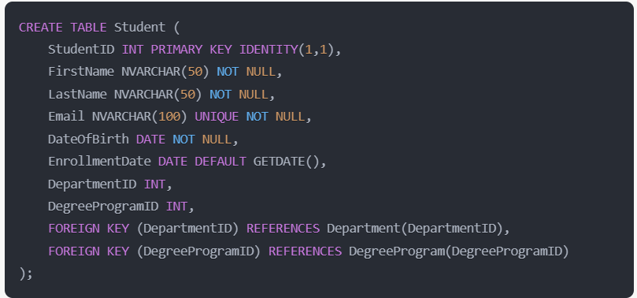

**Sample tools:** Erwin Data Modeler, Oracle SQL Developer Data Modeler, IBM Infosphere Data Architect, Toad Data Modeler, dbForge Studio

# Getting Started

Start off by gathering requirements from your stakeholders and creating a conceptual data model using tools you already have like PowerPoint, Word or Visio.

* Identify the key entities or objects in your system. Think about the "nouns" in the system such as Student, Course, Instructor, Department.
* Then determine the relationships and interactions between the entities such as a student enrolls in a course.
* Use simple diagrams to visualize the model. Draw boxes for entities and connect them with lines to show relationships. Label the lines with verbs or actions that describe the relationship. Now you’ve got a conceptual model!
* Continue to add details like the attributes of a student (e.g. name, email, phone) and the relationships like One-to-One, One-to-Many, and Many-to-Many. Identify the key fields and document everything using a tool like Visio or Erwin.
* Make sure to validate and maintain your model.

# Best Practices

1. **Start Simple:** Start with a conceptual model and expand gradually.Focus on mission essential and/or sensitive systems and identify key entities and relationships.
2. **Collaborate Early and Often:** Include both technical and non-technical stakeholders.
3. **Use Consistent Naming Conventions:** Ensure clarity and avoid confusion.
4. **Document Assumptions:** Keep track of decisions and their rationale.