What is NIEM?

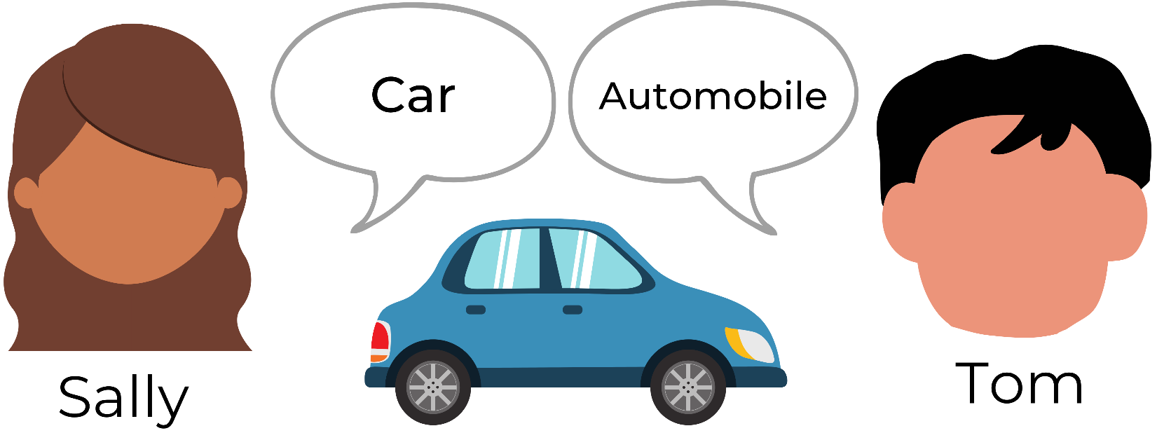The National Information Exchange Model (NIEM) helps different organizations share information **smoothly** and **consistently** by providing a **common vocabulary.**

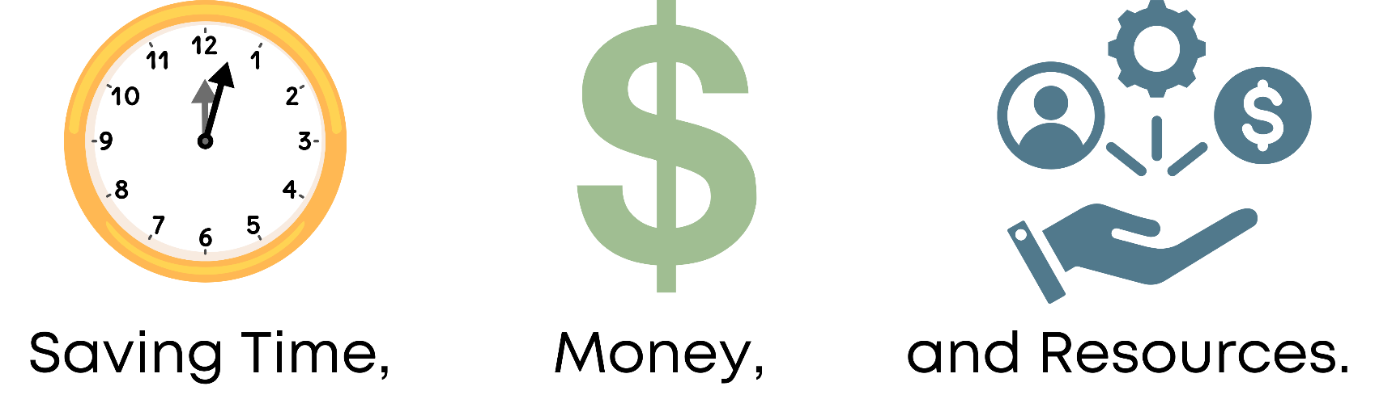So, when Sally and Tom exchange information, NIEM lets their systems understand each other, even if one says 'car' and the other says 'automobile.'

Contact today to get started with NIEM!